Ovo je zapravo Transformer Fleet Management Dashboard i po funkcionalnosti je između:
- SCADA
- Asset Performance Management (APM)
- Digital Twin
- Predictive Maintenance
Na temelju ove slike napravio bih sljedeću Quasar arhitekturu.
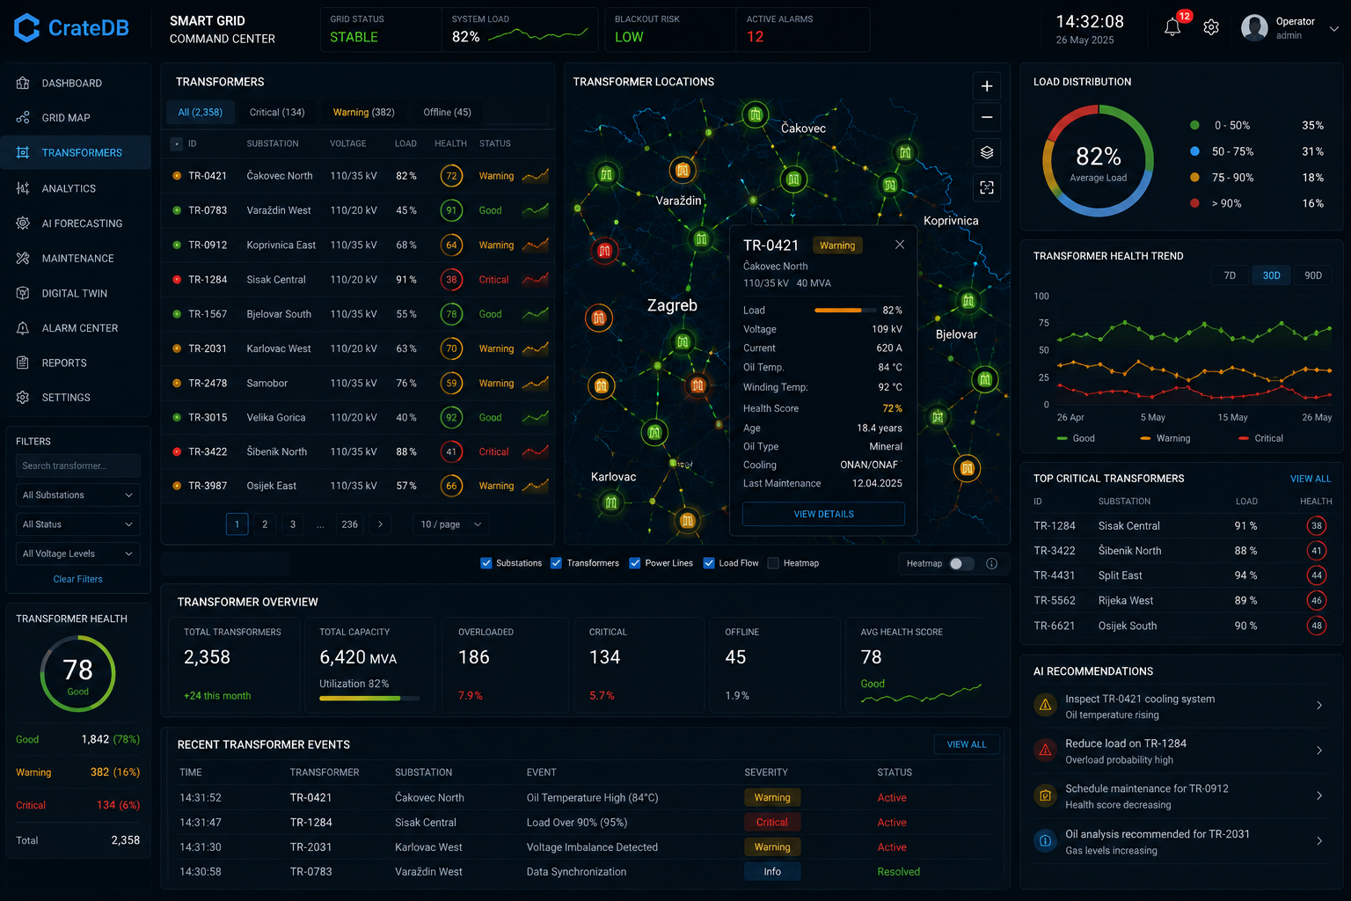

Struktura
src/  ├── pages/  │  │ └── Transformers.vue  │  ├── components/transformers/  │  │ ├── TransformerTable.vue  │ ├── TransformerMap.vue  │ ├── TransformerOverview.vue  │ ├── TransformerHealthCard.vue  │ ├── TransformerHealthTrend.vue  │ ├── TransformerDistribution.vue  │ ├── CriticalTransformers.vue  │ ├── TransformerEvents.vue  │ ├── AIRecommendations.vue  │ ├── TransformerDetailsDialog.vue  │ └── TransformerFilters.vue  │  ├── stores/  │  │ ├── transformerStore.js  │ ├── websocketStore.js  │ └── mapStore.js  │  ├── services/  │  │ ├── api.js  │ ├── websocket.js  │ └── crateQueries.js  │  └── router/ | 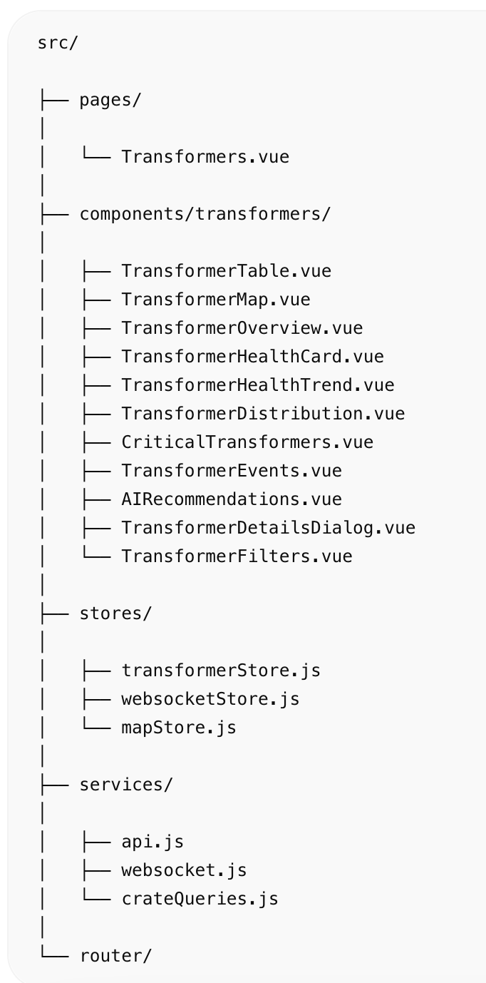

Transformers.vue
<template>  <q-page class="bg-dark text-white q-pa-md">  <div class="row q-col-gutter-md">  <!-- LEFT -->  <div class="col-2">  <TransformerFilters />  <TransformerHealthCard />  </div>  <!-- CENTER -->  <div class="col-7">  <TransformerTable />  <TransformerOverview />  <TransformerEvents />  </div>  <!-- MAP -->  <div class="col-3">  <TransformerMap />  <TransformerDistribution />  <TransformerHealthTrend />  <CriticalTransformers />  <AIRecommendations />  </div>  </div>  </q-page>  </template> | 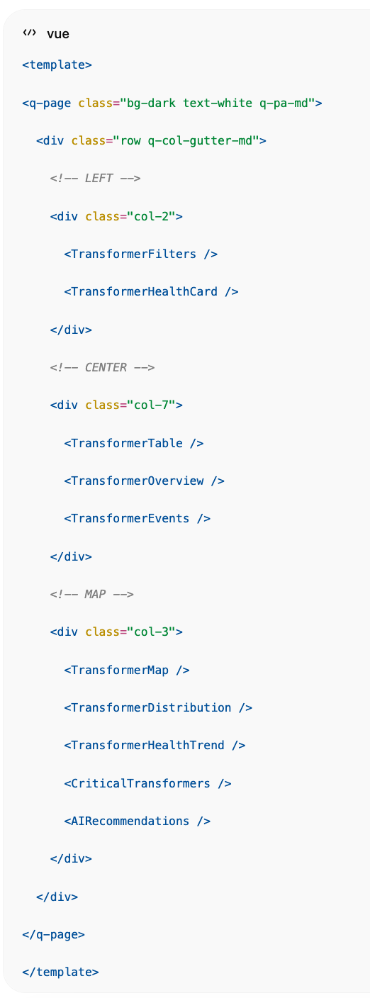

TransformerTable.vue
Glavni fleet pregled.
<template>  <q-card dark bordered class="bg-grey-10">  <q-card-section>  <div class="row justify-between">  <div class="text-h6">  Transformers  </div>  <q-input  dense  dark  outlined  v-model="search"  placeholder="Search..."  />  </div>  </q-card-section>  <q-table  dark  flat  bordered  :rows="rows"  :columns="columns"  row-key="id"  >  <template v-slot:body-cell-health="props">  <q-td>  <q-circular-progress  :value="props.row.health"  size="40px"  show-value  :color="healthColor(props.row.health)"  >  {{ props.row.health }}  </q-circular-progress>  </q-td>  </template>  </q-table>  </q-card>  </template> | 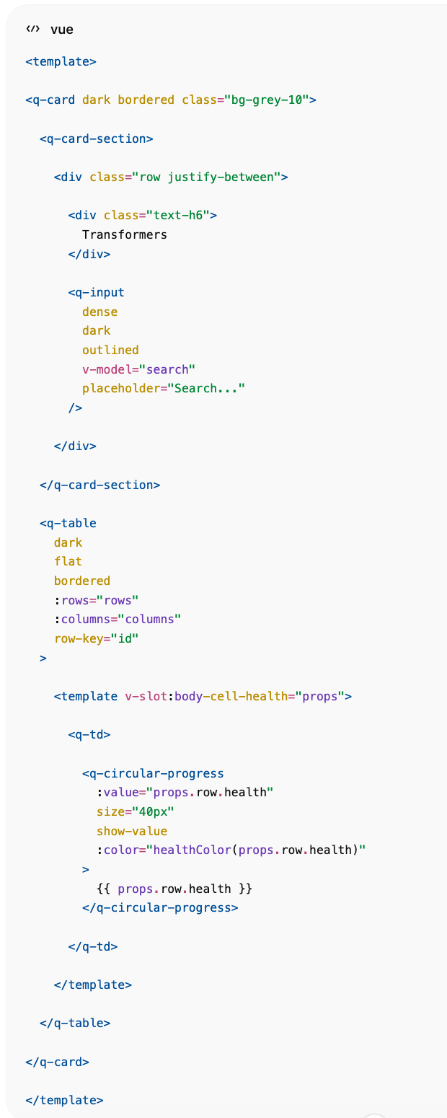

TransformerMap.vue
Map panel iz centra slike.
Za produkciju:
npm install mapbox-gl
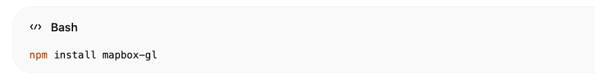
<template>  <q-card dark bordered>  <q-card-section>  Transformer Locations  </q-card-section>  <div id="map"></div>  </q-card>  </template>  <style scoped>  #map{  height:540px;  }  </style> | 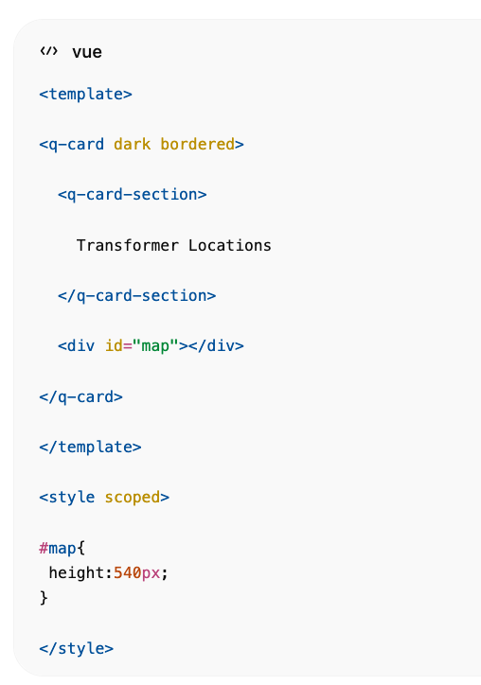

TransformerDetailsDialog.vue
Klik na TR-0421.
<q-dialog v-model="show">
<q-card
dark
style="width:450px"
>
<q-card-section>
<div class="text-h6">
TR-0421
</div>
<q-badge color="orange">
Warning
</q-badge>
</q-card-section>
<q-list>
<q-item>
<q-item-section>
Load
</q-item-section>
<q-item-section side>
82%
</q-item-section>
</q-item>
<q-item>
<q-item-section>
Voltage
</q-item-section>
<q-item-section side>
109 kV
</q-item-section>
</q-item>
<q-item>
<q-item-section>
Oil Temperature
</q-item-section>
<q-item-section side>
84°C
</q-item-section>
</q-item>
<q-item>
<q-item-section>
Health Score
</q-item-section>
<q-item-section side>
72%
</q-item-section>
</q-item>
</q-list>
<q-card-actions>
<q-btn
color="primary"
label="Digital Twin"
/>
</q-card-actions>
</q-card>
</q-dialog>

TransformerOverview.vue
Donji KPI panel.
<template>
<div class="row q-col-gutter-md">
<div
class="col"
v-for="item in overview"
:key="item.title"
>
<q-card dark bordered>
<q-card-section>
<div class="text-caption">
{{ item.title }}
</div>
<div class="text-h4">
{{ item.value }}
</div>
</q-card-section>
</q-card>
</div>
</div>
</template>
<script setup>
const overview = [
{
title:'Total Transformers',
value:'2,358'
},
{
title:'Capacity',
value:'6,420 MVA'
},
{
title:'Overloaded',
value:'186'
},
{
title:'Critical',
value:'134'
},
{
title:'Offline',
value:'45'
},
{
title:'Health Score',
value:'78'
}
]
</script>

TransformerHealthTrend.vue
ECharts.
npm install echarts vue-echarts
<template>
<q-card dark bordered>
<q-card-section>
Transformer Health Trend
</q-card-section>
<v-chart
:option="option"
style="height:250px"
/>
</q-card>
</template>
Prikazuje:
- Good
- Warning
- Critical
kao na slici.

CriticalTransformers.vue
<template>
<q-card dark bordered>
<q-card-section>
Top Critical Transformers
</q-card-section>
<q-list separator>
<q-item
v-for="item in transformers"
:key="item.id"
>
<q-item-section>
{{ item.id }}
</q-item-section>
<q-item-section side>
<q-badge color="red">
{{ item.health }}
</q-badge>
</q-item-section>
</q-item>
</q-list>
</q-card>
</template>

AIRecommendations.vue
<template>
<q-card dark bordered>
<q-card-section>
AI Recommendations
</q-card-section>
<q-list separator>
<q-item
v-for="item in recommendations"
:key="item.title"
>
<q-item-section>
<div>
{{ item.title }}
</div>
<div class="text-grey">
{{ item.description }}
</div>
</q-item-section>
</q-item>
</q-list>
</q-card>
</template>

Realtime EMQX Feed
// services/websocket.js
const ws = new WebSocket(
'ws://localhost:8000/ws/transformers'
)
ws.onmessage = (event)=>{
const data = JSON.parse(event.data)
transformerStore.update(data)
}

CrateDB upiti

Fleet Health
SELECT
AVG(health_score)
FROM transformers;

Warning
SELECT COUNT(*)
FROM transformers
WHERE health_score BETWEEN 50 AND 80;

Critical
SELECT COUNT(*)
FROM transformers
WHERE health_score < 50;

Map Layer
SELECT
transformer_id,
lat,
lon,
health_score,
load_percent
FROM transformers;

Digital Twin integracija
Klik na transformator:
TR-0421
otvara:
/transformers/TR-0421
gdje se otvara:
- 3D transformer model
- svi senzori
- oil analytics
- DGA analytics
- maintenance history
- AI predictions
- RUL prediction
- failure probability
- work orders
- alarm history
Točno kao enterprise utility Asset Performance Management platforma za CrateDB Smart Grid demonstrator.
窗体顶端

窗体底端

